Assignment -4 BATCH NO : B9-3A5E

|  |  |
| --- | --- |
| Assignment Date | 19 October 2022 |
| Student Name | Ashish AL |
| Student Roll Number | 9622192050012 |
| Maximum Marks | 2 Marks |

WokWi Link : https://wokwi.com/projects/347843333031199315 Program :

#include <WiFi.h>

#include <PubSubClient.h> #include <ArduinoJson.h>

WiFiClient wifiClient; #define ORG "7h1uma"

#define DEVICE_TYPE "eps32"

#define DEVICE_ID "12345"

#define TOKEN "123456789"

#define speed 0.034

char server[] = ORG ".messaging.internetofthings.ibmcloud.com"; char publishTopic[] = "iot-2/evt/Data/fmt/json";

char topic[] = "iot-2/cmd/home/fmt/String"; char authMethod[] = "use-token-auth";

char token[] = TOKEN;

char clientId[] = "d:" ORG ":" DEVICE_TYPE ":" DEVICE_ID;

PubSubClient client(server, 1883, wifiClient); void publishData();

const int trigpin=5; const int echopin=18; String command;

String data="";

long duration; int dist;

void setup()

{

**Serial**.begin(115200);

pinMode(trigpin, OUTPUT); pinMode(echopin, INPUT); wifiConnect();

mqttConnect();

}

void loop() {

publishData(); delay(500);

if (!client.loop()) { mqttConnect();

}

}

void wifiConnect() {

**Serial**.print("Connecting to "); **Serial**.print("Wifi"); WiFi.begin("Wokwi-GUEST", "", 6);

while (WiFi.status() != WL_CONNECTED) { delay(500);

**Serial**.print(".");

}

**Serial**.print("WiFi connected, IP address: ");

**Serial**.println(WiFi.localIP());

}

void mqttConnect() {

if (!client.connected()) {

**Serial**.print("Reconnecting MQTT client to "); **Serial**.println(server); while (!client.connect(clientId, authMethod, token)) {

**Serial**.print("."); delay(1000);

}

initManagedDevice();

**Serial**.println();

}

}

void initManagedDevice() {

if (client.subscribe(topic)) {

**Serial**.println(client.subscribe(topic)); **Serial**.println("subscribe to cmd OK");

} else {

**Serial**.println("subscribe to cmd FAILED");

}

}

void publishData()

{

digitalWrite(trigpin,LOW); digitalWrite(trigpin,HIGH); delayMicroseconds(10);

digitalWrite(trigpin,LOW);

duration=pulseIn(echopin,HIGH); dist=duration*speed/2;

if(dist<100){

DynamicJsonDocument doc(1024);

String payload;

doc["AlertDistance:"]=dist; serializeJson(doc, payload); delay(3000);

**Serial**.print("\n");

**Serial**.print("Sending payload: ");

**Serial**.println(payload);

if (client.publish(publishTopic, (char*) payload.c_str())) {

**Serial**.println("Publish OK");

} else {

**Serial**.println("Publish FAILED");

}

}

}

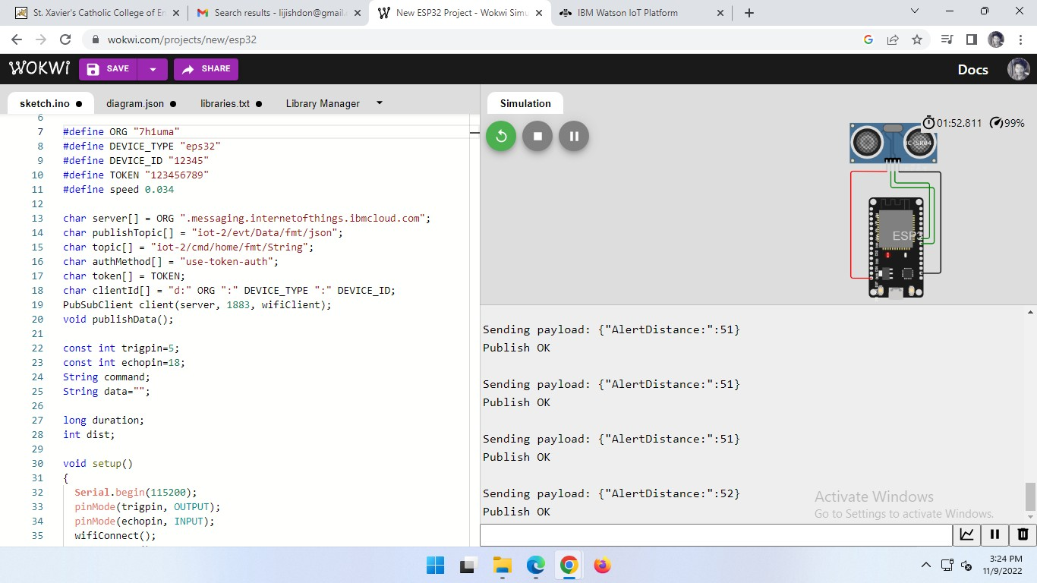Output :

